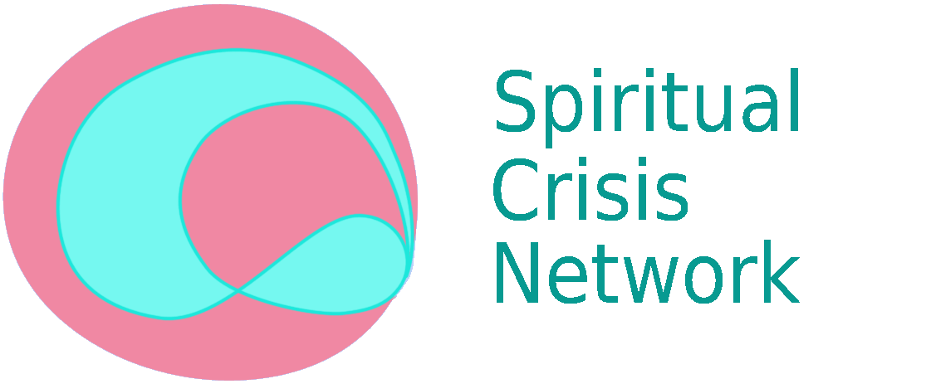

Managing the Threshold
Saturday 7th October
Between everyday reality and that encountered in Spiritual Crisis (sometimes labelled psychosis).
Daniel Hadjiandreou and Isabel Clarke
7.00 - 9.00 p.m. Kingsley Hall, Bromley-by-Bow.
More details: http://spiritualcrisisnetwork.uk/event/volunteer-social-day/
From his own intense and chaotic personal experience, Daniel Hadjiandreou shares what may occur when rapid opening to other dimensions happens without the skills and support of a loving, understanding community. He offers some suggestions on how this journey can be smoother and less traumatic.
Isabel Clarke will put such journeys into another realm of experience into a context that places them at the heart of being human - and invites a radical new look at what it is to be human.

Free for SCN members and friends.
£5 for others.

