USING EMOTIONS POSITIVELY: How clinical psychologists can apply behaviour change skills in the service of CLIMATE CRISIS mitigation.

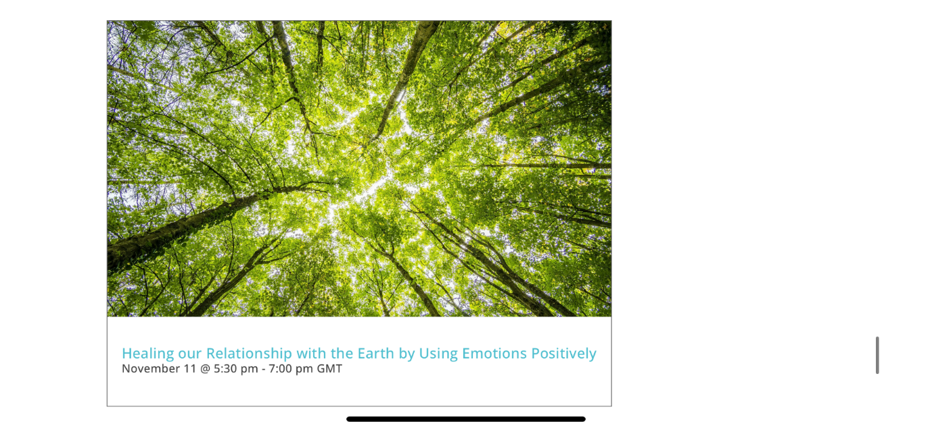

Our work as psychologists often concerns healing relationships, primarily peoples’ relationships with themselves and with others. The climate emergency alerts us that the relationship between human beings and the planet on which we depend for life is in serious need of healing. How can we, as psychologists, contribute our unique skills to this healing work? This webinar suggests ways in which that we can do so by using emotions positively to promote behaviour changes that will help to mitigate the climate crisis.

**Speaker:**  
Isabel Clarke is a Consultant Clinical Psychologist with over 30 years of experience in the NHS, where she developed the innovative, trans-diagnostic ‘Comprehend, Cope and Connect’ (CCC) model. This model combines various third-wave CBT approaches to form a trauma-informed, mindfulness-based framework. Her approach is detailed in her 2021 book, Meeting Mental Breakdown Mindfully. Isabel has also applied the CCC model and her insights on the psychology of spirituality (as seen in ‘Psychosis and Spirituality,’ Clarke 2010; ‘Madness, Mystery and the Survival of God,’ Clarke 2008) to address the climate crisis, drawing on her environmental activism since the 1990s.

**BOOK  HERE:** [**Healing our Relationship with the Earth by Using Emotions Positively - ACP UK**](https://acpuk.org.uk/event/healing-our-relationship-with-the-earth-by-using-emotions-positively/)

Cost: Free to ACP members. £30 for others.